Distributed: Feb 16, 2015

Due: Feb. 23, 2015

**Design Problem 3: Understanding Aberrations via Lens Modules**

A skill that is often overlooked for the optical designer is the ability to identify third-order aberrations from spot diagrams and ray fan diagrams. In this design problem you will be using “lens modules” to simulate the effects of third-order aberrations. By simulating pure third-order aberrations, you will be able to see how an aberration manifests itself in the ray fan diagram and the spot diagram. In addition, you’ll become more familiar with the common analysis options in CODE V.

A lens module is a “black box” lens representation that obeys the laws of optics and the limitations they impose:

* A lens that is perfect at one conjugate, cannot be perfect at another conjugate
* A perfect lens is completely defined by specifying all of the following:
  + Focal length
  + Principal plane locations
  + The single conjugate at which it is perfect
  + Entrance pupil location
  + Spherical aberration of the pupil

Lens modules are commonly uses to simulate the behavior of conceptual lenses or existing lens assemblies that can be only measured as an assembly (ie. no lens prescription information is available). Specifically, selected third-order aberrations, operation at various conjugates, and pupil shift can be studied without having an actual lens. Aberration magnitudes are defined in waves of error at the edge of the pupil.

First-order lens parameters:

* focal length: 200mm
* F/number: 4
* Spectral band: d-line
* Semi-FOV: 10°
* Use a paraxial image solve to set focus
* Object distance: infinity

Analysis graphics:

* Lens layout
* List third-order transverse ray aberrations- all surfaces
* Ray Fan diagram (scale 0.02mm/in)
* OPD diagram (scale 1wv/in)
* Through-focus spot diagram with airy disc indicated
  + (5 locations: -0.10, -0.05, 0.00, +0.05, +0.10)

1. Third-order spherical aberration

Define a lens module with the first-order properties specified above. Add 0.5 wave of third-order spherical aberration. Note: when defining aberrations in a lens module, be sure to define the field and module EPD values that correspond to the first-order properties of your lens. Generate the analysis graphics listed above.

* 1. With the object distance at infinity, generate the analysis graphics listed above
     1. How does the aberration change as a function of field?
     2. How would the aberration change if a smaller f/number was used?
  2. Now change the object distance to 2000 mm
     1. What changes do you notice in the aberration content of the lens?
     2. How do the ray fan diagrams and spot diagrams compare the infinite conjugate case?
  3. Now move the aperture stop 20 mm in front of the lens module.
     1. What changes do you notice in the aberration content of the lens?
     2. How do the ray fan diagrams and spot diagrams compare the infinite conjugate case?
  4. Return to a infinite object conjugate, with the aperture stop at the front of the lens module and add  **1.5 waves** of spherical aberration. We will now simulate the effect of spherical aberration on an image using a the “Image Simulation” feature in CODE V. The 2D Image Simulation (IMS) option simulates the appearance of a 2D input object as it is imaged through the optical system defined in CODE V. For example, if you have a fisheye lens defined in CODE V, you can define a 2D object for input into the IMS feature, and the program will show you how that object will be imaged by the fisheye lens, including distortion and other effects. Refer to the IMS description in the on-line CODE V reference manual for a comprehensive description of this feature.
     1. Activate “2D Image Simulation” using the pull down menus:

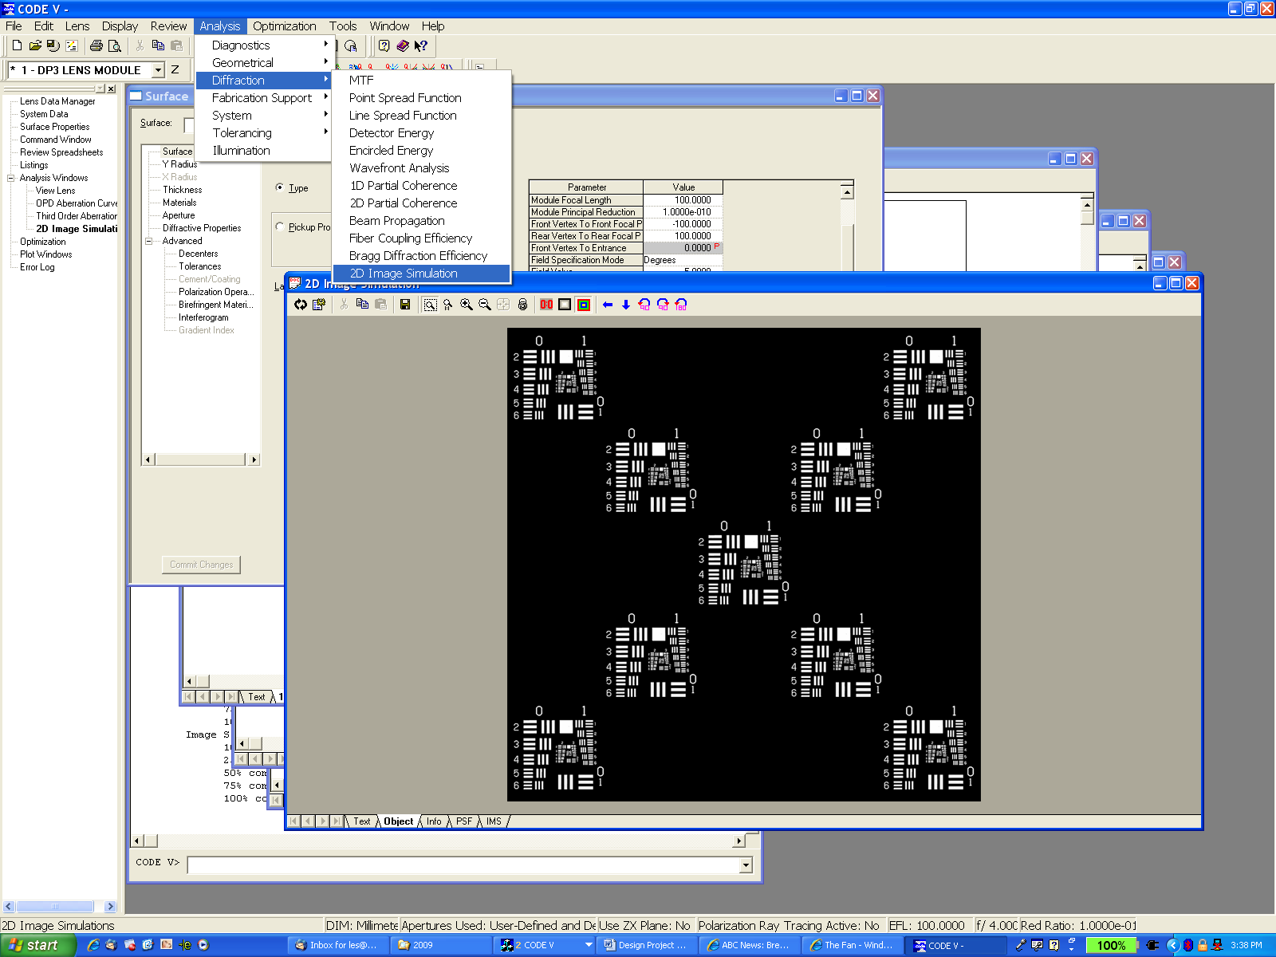

* + 1. Open the “USAF1951_array.bmp” image file as the object to be simulated

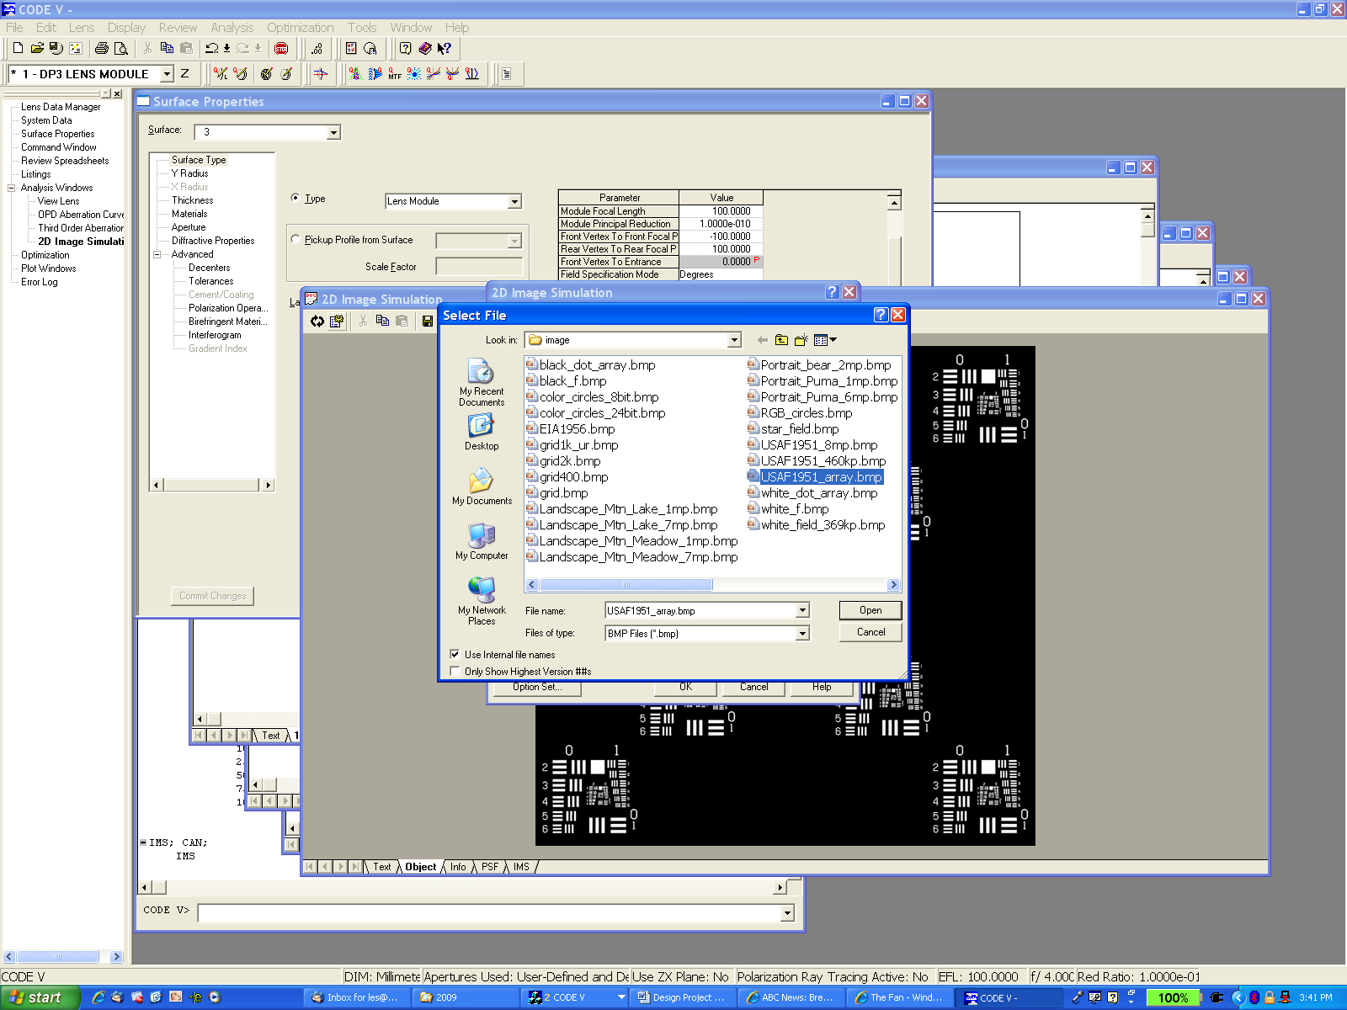

* + 1. To run IMS, click the “OK” radio button and CODE V will produce a simulation how this object file will be imaged by your lens.
    2. Compare the original object file with the “IMS” file. What observations do you note about the image produced by the lens?
    3. The object file in (iii-iv) covers the entire image plane and as such the feature sizes of this object file are rather large. Thus, the image produced with 1 waves of SA does not look degraded. Now change the size of the object file to cover a semi-field paraxial image semi-diameter of 5mm and displace the field to the corner of the format (X-Offset=30, Y-Offset=30):

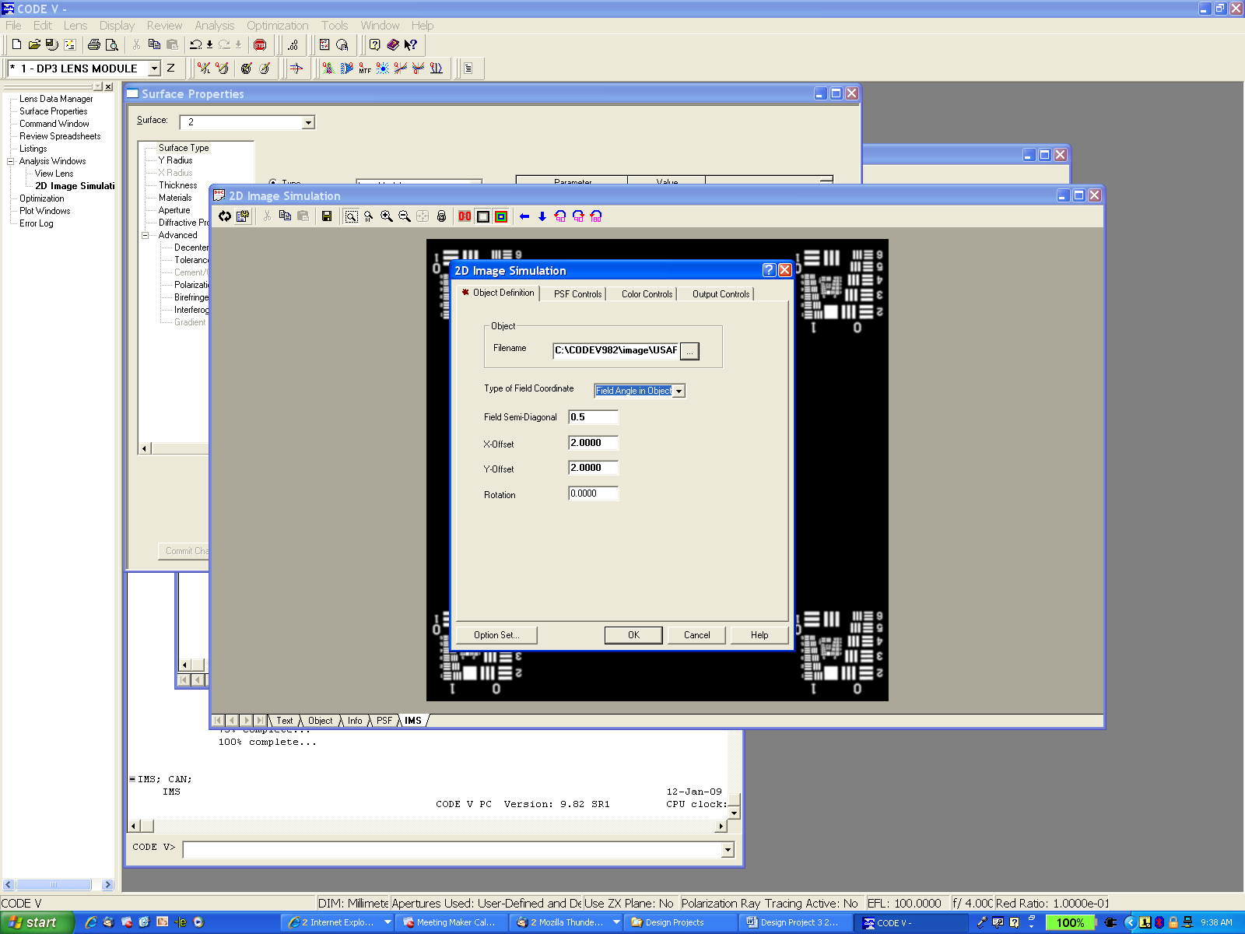

Full Field

Image Plane

30 mm

30 mm

7.07mm07

Object

What do you now observe about the image produced the lens module?

1. Third-order coma
   1. With the object distance at infinity, Add 0.5 wave of third-order coma and generate the analysis graphics listed above
      1. How does the aberration change as a function of field?
      2. How would the aberration change if a smaller f/number was used?
   2. Now change the object distance to 1000mm
      1. What changes do you notice in the aberration content of the lens?
      2. How do the ray fan diagrams and spot diagrams compare the infinite conjugate case?
   3. Now move the aperture stop 20 mm in front of the lens module.
      1. What changes do you notice in the aberration content of the lens?
      2. How do the ray fan diagrams and spot diagrams compare the infinite conjugate case?
      3. Return the object to infinity and the aperture stop to the front of the lens module. Add  **3 waves** of coma and repeat the IMS procedure described in (1d). Compare the original object file with the “IMS” file. What observations do you note about the image produced by the lens?
2. Plot W(xp, yp), W(xp,0) and W(0, yp). Assume magnitude of each aberration coefficients is 1, and H=1.

|  |  |  |  |
| --- | --- | --- | --- |
|  | W(xp, yp) | W(xp,0) | W(0, yp) |
| W020:  Defocus |  |  |  |
| W040: Spherical Aberration |  |  |  |
| W131: Coma |  |  |  |
| W220: Field Curvature |  |  |  |
| W222: Atigmatism |  |  |  |
| W311: Distortion |  |  |  |

1. Fill the table

|  |  |  |
| --- | --- | --- |
|  | ex(xp,yp) | ey(xp,yp) |
| W020: Defocus |  |  |
| W040: Spherical Aberration | $$-4(\frac{R}{r_{c}})W_{040}({x_{p}}^{3}+x_{p}{y_{p}}^{2})$$ | $$-4(\frac{R}{r_{c}})W_{040}({y_{p}}^{3}+{x_{p}}^{2}y_{p})$$ |
| W131: Coma |  | $-\left(\frac{R}{r_{c}}\right)W_{131}{{H(x}_{p}}^{2}+{3y_{p}}^{2}$) |
| W220: Field Curvature |  | $$-2\left(\frac{R}{r_{c}}\right)W_{220 }H^{2}y_{p}$$ |
| W222: Atigmatism |  | $$-2\left(\frac{R}{r_{c}}\right)W_{222 }H^{2}y_{p}$$ |
| W311: Distortion |  | $$-\left(\frac{R}{r_{c}}\right)W_{311 }H^{3}$$ |

1. Fill the table

|  |  |  |
| --- | --- | --- |
|  | ex(xp,0) Saggital Ray Fan | ey(0,yp) Tangential Ray Fan |
| W020: Defocus |  |  |
| W040: Spherical Aberration | $$-4(\frac{R}{r_{c}})W_{040}{x_{p}}^{3}$$ | $$-4(\frac{R}{r_{c}})W_{040}{y_{p}}^{3}$$ |
| W131: Coma |  | $-\left(\frac{R}{r_{c}}\right)W_{131}{{H(x}_{p}}^{2}+{3y_{p}}^{2}$) |
| W220: Field Curvature |  | $$-2\left(\frac{R}{r_{c}}\right)W_{220 }H^{2}y_{p}$$ |
| W222: Atigmatism |  | $$-2\left(\frac{R}{r_{c}}\right)W_{222 }H^{2}y_{p}$$ |
| W311: Distortion |  | $$-\left(\frac{R}{r_{c}}\right)W_{311 }H^{3}$$ |

1. Plot ex(xp, 0) and ey(0, yp). Assume magnitude of each aberration coefficients is 1, and H=1, and F/#=1.

|  |  |  |
| --- | --- | --- |
|  | ex(xp,0): Saggital Ray Fan | ey(0,yp) Tangential Ray Fan |
| W020:  Defocus |  |  |
| W040: Spherical Aberration |  |  |
| W131: Coma |  |  |
| W220: Field Curvature |  |  |
| W222: Atigmatism |  |  |
| W311: Distortion |  |  |